***Tie One On, Gentlemen – A brief history of men’s ties***

*Middle School Reading Selection Kae Chatman*

Humans, even men, like to decorate their necks. The pharaohs of ancient Egypt wore gold and copper collar pieces to accessorize their immortality and political power. Ancient armies from China to Rome devised metal helmets and suits of armor to protect vulnerable body parts from spears and daggers. But what about ties? How do these knotted swaths of cloth fit into the fabric of manly apparel? 66

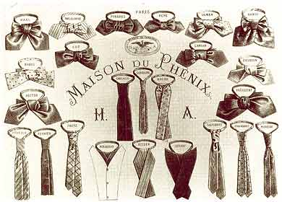

history-neckties

Ties date from 17th century Europe, where nations often fought over disputed boundaries of land and faith. During the Thirty Years War (1618-1648), France and Sweden were allied against the German-Austrian Habsburg Empire. Both sides supplemented their troops with mercenaries from Croatia (later called Yugoslavia). Croatian soldiers wore simple linen scarves called *cravats*. This neckwear caught the eye of fashion-forward French monarchs Louis XIII and his son, the “Sun King,” who ruled France from 1643-1715. By 1650, Louis XIV had transformed the humble *cravat* into a power tie. Portraits of the French monarch never show him bare-necked or without a wig piled high with ringlets. 105 + 66 = 171

Gentlemen’s portraits from 1650 forward reflect the French influence. To our eyes, King Louis’ lacy *cravat*s look a bit frilly for kingly attire, but make no mistake: These accessories symbolized wealth and high social status with the bonus of being more comfortable than stiff-collared shirts and easier to launder than collars after accidents with soup at supper. Middle class professionals throughout Europe and in the New World--doctors, lawyers, bankers—borrowed French fashion trends with colorful cravats of their own, which they arranged in ingenious designs. Even ordinary workmen took pains to drape and knot wool scarves below their chins to “dress up” in society with a splash of fashion. 110 + 171 = 281

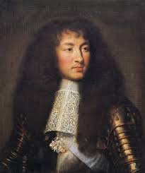 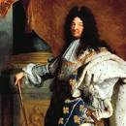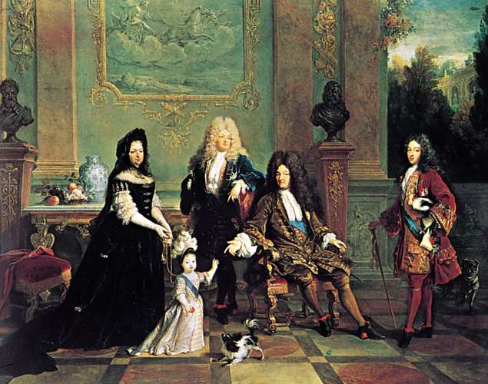

Louis XIV with his signature lace cravat. <https://www.britannica.com/topic/cravat>

.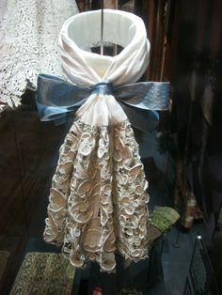

<http://thisisversaillesmadame.blogspot.com/2016/08/the-cravat.html>

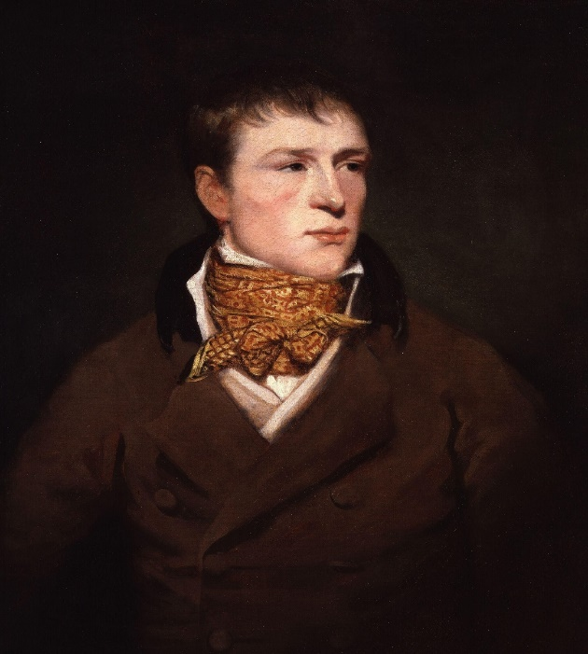

Portrait of boxer "Jem" Belcher wearing a patterned cravat and a double-breasted brown coat with a dark (fur or velvet?) collar, c. 1800. upload.wikimedia.org

<https://no.pinterest.com/pin/428475352018025614/>

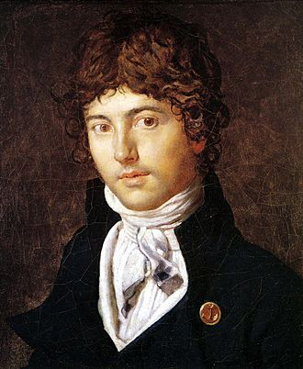

An 1800 portrait of French astronomer Pierre-François Bernier by Jean-Auguste-Dominique Ingres, from the collection of the Memorial Art Gallery of the University of Rochester in Rochester, New York, USA. Bernier is depicted wearing a cravat.

<https://en.wiktionary.org/wiki/cravat>

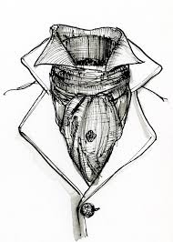

Cravat as worn in the 19th century: <https://en.wikipedia.org/wiki/Cravat>

See also: <https://www.tie-a-tie.net/the-evolution-of-the-necktie/#:~:text=The%20Origin%20of%20the%20Necktie,as%20part%20of%20their%20uniform.>

In the 19th century, English gentlemen began to classify all cravats, scarves, and bows as ties and to seek out expert advice on how best to knot them in the Ascot, the Windsor, the Half Windsor, and the Four-in-Hand. (Updated versions of these British fashion screeds are available on YouTube for Americans who need them.)

But not every Brit approved of bow ties with foppish knots. The 1818 publication *Neckclothitania* satirized dandies who fussed over their neckwear. Anti-dandyism grew in England as Beau Brummell, a boyhood chum of the future King George IV, became a fashion avatar for young men eager to imitate his stylish clothes, floppy bow ties, witty gossip, and intemperate spending, all of which led Mr. Brummell into poverty, insanity, and an untimely death in France. 129+ 281 = 410

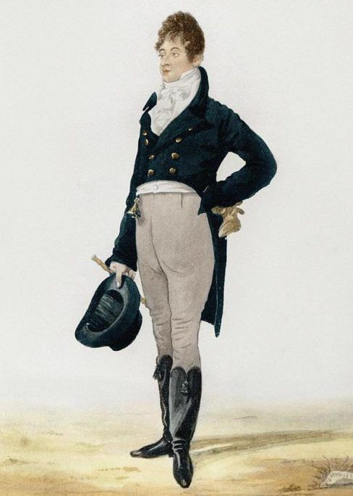

**Likeness of Beau Brummell**

**(published often with no single owner)**

<https://www.gentlemansgazette.com/beau-brummell-the-original/>

After 1830, aristocratic excess encouraged a return to a sober style of dress for men in England. The Ascot tie required a stick pin to hold its shape, but the effect was not terribly showy, and the simple, black string tie, popular in the American West, worked well with a top coat. Queen Victoria’s consort, the circumspect Prince Albert, contributed a variation on the Double-Four-In-Knot tie and otherwise found fame in America where his photograph appeared on cans of loose tobacco. 81 + 410 = 491

Men’s interest in fashion got off to a slow start in the USA, according to historian Walter Nelson, who observes that

In the 1860s, almost every man in America looks like they slept in their clothes, and even major government officials appear in rumpled and stained clothing with unkempt stringy hair - and vests invariably have two or three buttons unbuttoned. About 1870, there is a change and men's styles become more and more about looking tidy and well groomed. Hair becomes shorter and nicely combed and oiled, facial hair becomes less effusive and more trimmed, vests get fully buttoned and clothing becomes better fitted and crisper. **107 + 491 = 597** (<http://walternelson.com/dr/node/211>).

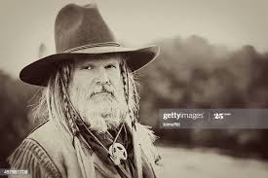

Replace: Getty images.com

The 20th century offered novel options in American male grooming. During the roaring twenties, a Gatsby-like dandyism appealed to a few city slickers and owners of speakeasies. Then came the Depression and World War II, after which dawned America’s Golden Age. American men attended college on the GI Bill and headed to work in fitted suits and skinny ties. The sixties kids rebelled with wildly colored ties so wide they could have been parachutes. In the 1970’s-80’s, American men were counseled to explore their own inner tie—wide, thin, somewhere in the middle, or joyfully tie-free in a dashiki? Those who loved and lost their 1990’s ties and remember what they looked like can shop to replace them from the vintage collections on Etsy. **120 + 597 = 717**

In the 2000’s, there is talk that ties no longer count. Can a man go on a first date without a tie? Can he get married tieless in Las Vegas? Have ties lost their social significance as markers of masculinity, social status, and urbane sophistication? Nowadays, even ex-presidents travel the world tieless. Seriously? What is happening? **56 + 717 = 773**

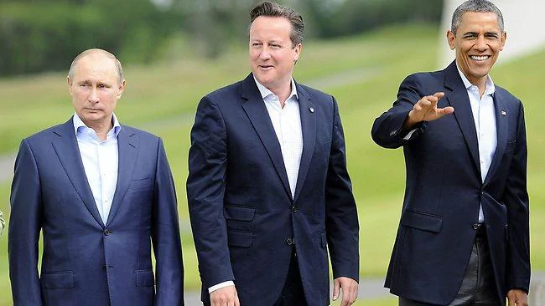

Only time will tell, but ask yourself, what does fashion history teach us, if not how confusedly we want our clothes to reveal and conceal us, to grow beyond convention or return to something traditional, to expand and contract, to go bright and then dark? Do we humans really need clothes to mark our gender, social status, ethnic background, or politics? Or are they akin to avian plumage, just another way to attract attention?  **(847 words)**

**Quiz 1 Tie One On, Gentlemen – A brief history of men’s ties**

**1. Ties date from the Thirty Years War (1618-1648) in Europe when France and Sweden were allied against _________________.**

A Russia and Turkey

B Italy and Spain

**C the German-Austrian Habsburg Empire**

D England and Canada

**2. Mercenary soldiers from Croatia wore simple linen scarves, which the French called _______.**

A String ties

**B Cravats**

C Ascots

D Beau Brummells

**3. All portraits of King Louis XIV of France, the “Sun King,” show him wearing __________.**

**A A cravat made of white lace**

B A gold and copper neckplate

C Shoes with gold buckles

D A gold crown with rubies

**4. Louis XIV’s dramatic wigs and elaborate neckwear were intended to symbolize**

A The Sun King’s love for his grandmother

B The French king’s keen interest in opera

C The French fashion industry’s desire to increase sales in foreign markets

**D The enormous wealth and power of the French king**

**5. Why did English gentlemen begin to seek instruction on how to knot and arrange their ties?**

**A Neckwear in the 1800’s featured ties with elaborate knots like the Windsor**

B Tying complex knots in ties was thought to prepare men to serve in the British navy

C Factory work called for men with dexterity, which could be gained by knotting ties

D Young men in 19th century England aspired to be dandies, and those lads knew how to tie ties

**6. Why did young Englishmen in the early 19th century admire Beau Brummell?**

A He wore stylish clothes, including fancy bow ties

B He was friendly with the future King George IV

C He was witty and a great source of gossip

**D All of the above**

**7. Why did fashion for British men take a turn toward less flamboyant neckwear after 1830?**

A The British were miserably poor and could ill afford silk ties or patterned scarves.

**B The scandals surrounding Beau Brummell gave fashion “dandies” a bad name.**

C Queen Victoria hoped to encourage English youths to devote themselves to their school work.

D British fashion could not compete against the better-made French ties, cuffs, and boots.

**8. Fashion historian Walter Nelson complained that American men in the 1860’s appeared to have slept in their clothes. What did Nelson overlook about American society in the 1860’s?**

A American men were untidy in 1860, and they still are, with little change over the decades.

B In the 1860’s, most American men were farmers whose only clothes were overalls.

C In the 1860’s, few American men knew how to wash clothes, so they just stayed dirty.

**D In the 1860’s, Americans fought a civil war, leaving many with few chances to change clothes or wash their hair regularly.**

**9. When in the 20th century was America’s Golden Age?**

A In the decade following the end of World War II

B At the time when American men attended college on the GI Bill

C When upwardly mobile men wore fitted suits and skinny ties

**D All of these answers conform to the essay writer’s view of the 1950’s**

**10. What might the end of tie-wearing signify about 21st century American culture?**

A Significant change in whether American men still value their masculinity and social status

**B Emergence of a new class of powerful men who do not need ties to signal their social status**

C A new era of universal equality, world peace, and prosperity for men of every nation

D A desire for men’s clothing that is comfortable, figure-flattering, and low-maintenance